(Approx. 259 words)

How do I add additional Time Zones in Windows?
By Rosita Herrick, Forum Leader, Sarasota Technology UG, FL
August 2018 issue, STUGMonitor
www.thestug.org
hrosita (at) aol.com

Learn how to set up a second clock and customize sounds by application.

1. Set a second clock

Many of us have friends or relatives in other time zones and have trouble remembering the difference between our time and their time; for example, in Arizona. I chose Arizona because it does not have Daylight Savings Time.

Here are the steps:

Right click on the time displayed in the lower right corner of your screen.
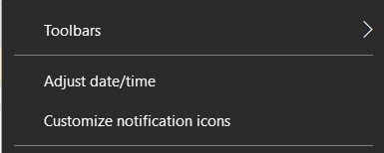

Look for the phrase, Adjust Date/Time, and click on it.
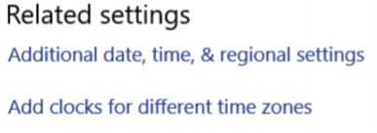
In the popup window, find the following item on the right side of the window:

Click on ‘Add clocks for different time zones’. In the next popup window, click on the caret showing in the box and a list of different time zones will be displayed. Click on the time zone you want to see when you display the time on the status bar.
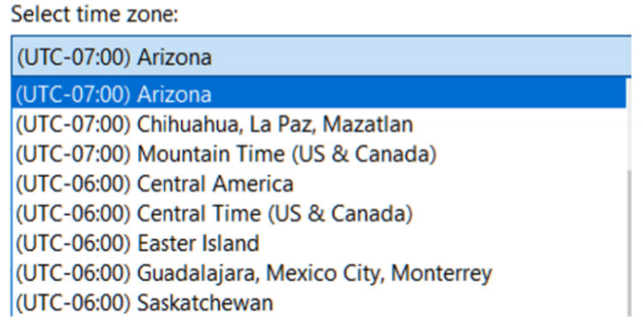

As you can see, I chose Arizona. I also changed the ‘clock 2’ name to Arizona. Now click the OK button, and the next time you hover the mouse over the time, you will see the following:
By the way, on the same page you can change date formats.
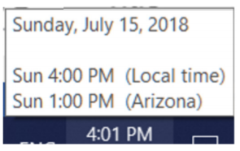



2. Adapting sound by application

Right click on the speaker icon and then on Open Volume Mixer.
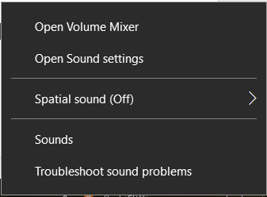

Each application blue arrow can be moved up or down to increase or decrease the sound for that application.
